**LAB 6**

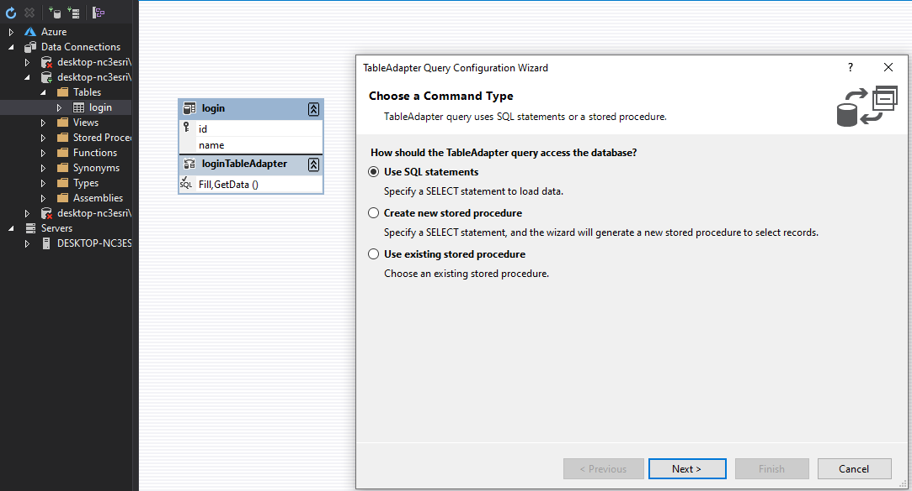

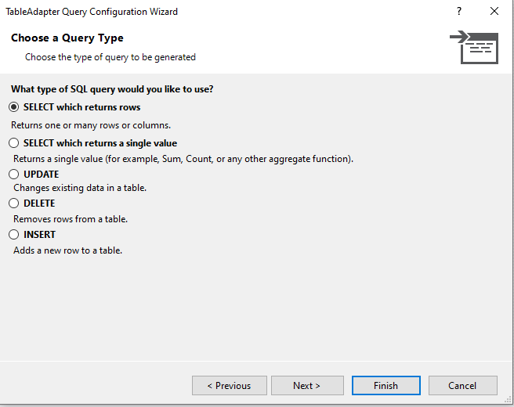

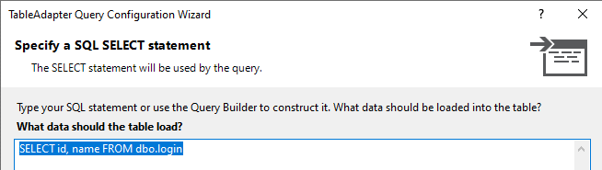

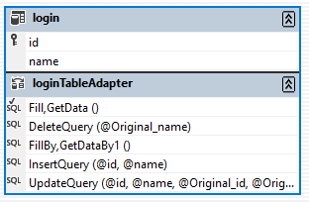

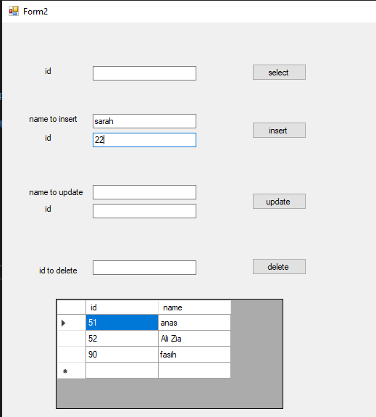

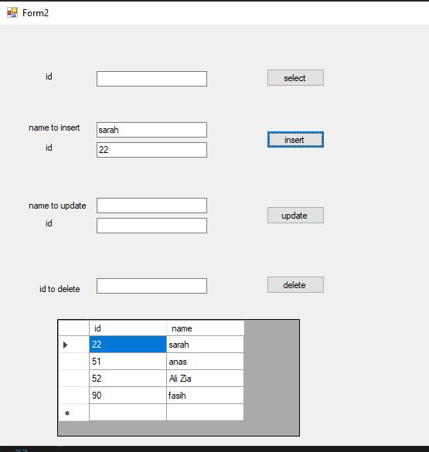

**CODE**

using System;

using System.Windows.Forms;

using DC_labtask.DataSet1TableAdapters;

namespace DC_labtask

{

public partial class Form2 : Form

{

public Form2()

{

InitializeComponent();

}

private void button1_Click(object sender, EventArgs e)

{

int a = int.Parse(textBox1.Text);

loginTableAdapter d = new loginTableAdapter();

dataGridView1.DataSource = d.GetDataBy(a);

}

private void button2_Click(object sender, EventArgs e)

{

int b= int.Parse(textBox2.Text);

DataSet1TableAdapters.loginTableAdapter ob = new DataSet1TableAdapters.loginTableAdapter();

ob.InsertQuery(b, textBox3.Text);

}

private void button3_Click(object sender, EventArgs e)

{

int c = int.Parse(textBox4.Text);

DataSet1TableAdapters.loginTableAdapter ab = new DataSet1TableAdapters.loginTableAdapter();

ab.DeleteQuery(c);

}

private void button4_Click(object sender, EventArgs e)

{

int d = int.Parse(textBox5.Text);

DataSet1TableAdapters.loginTableAdapter n= new DataSet1TableAdapters.loginTableAdapter();

n.UpdateQuery(textBox6.Text, d);

}

private void Form2_Load(object sender, EventArgs e)

{

this.loginTableAdapter.Fill(this.DataSet1.login);

}

}

}